MOTOR WIRES

* red motor (+ and - switching can control CW/CCW)
* black encoder -(GND, “can not be connected wrong” I assume means that reversing the vcc and gnd means the motor moves backward)
* YELLOW encoder A phase (11 signals)
* GREEN encoder B phase (11 signals)
* blue encoder + (+ and - can not be connected wrong)
* white motor -(+ and - switching can control CW/CCW)

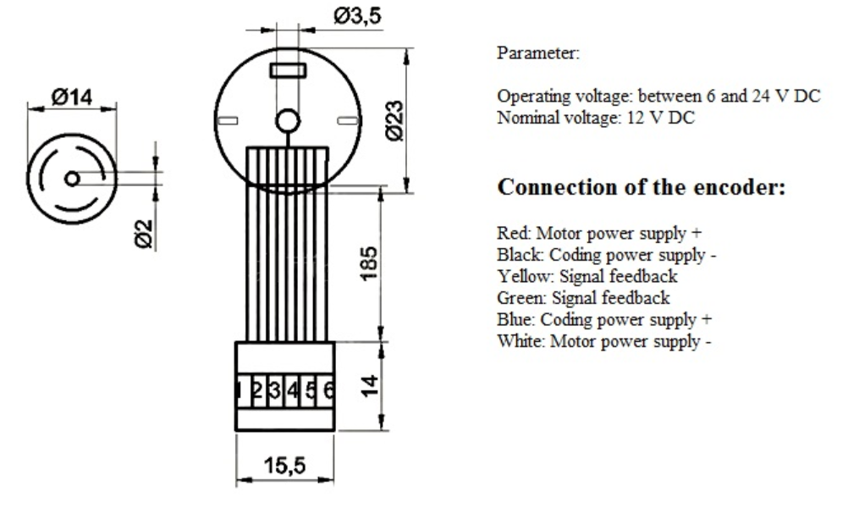

<https://www.openimpulse.com/blog/wp-content/uploads/wpsc/downloadables/JGA25-371-technical-drawing-21.jpg>

Interrupt pins on Arduino Mega: 2&3, 18&19, 20&21

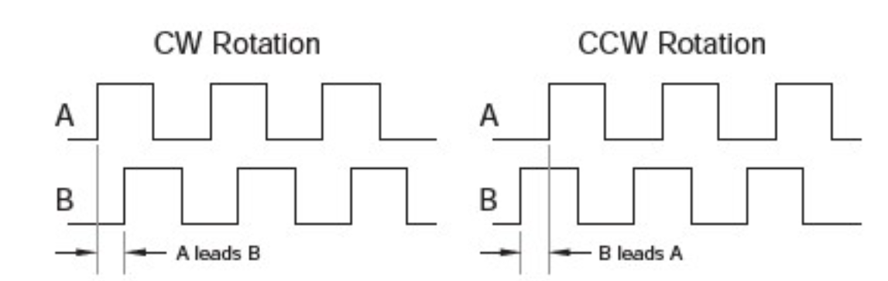

* ONE ROTATION OF OUR BIG ASS WHEEL IS 950 ENCODER TICKS!!!!
* LOW is 0-255
* HIGH is 255-0